
Parklands
Junior School

Parent/Carer/Visitor
Behaviour Policy

Inspiring Success

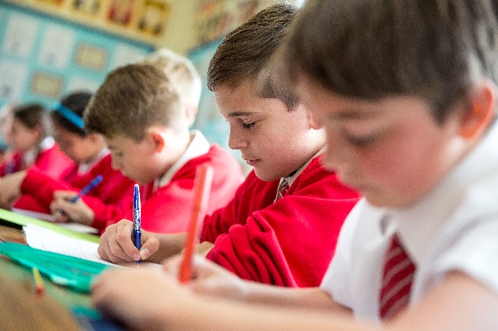


Parklands Junior School

Policy on Behaviour of Parents/Carers and Visitors to Our School

At Parklands Junior School we actively encourage close links with parents and the community. We believe that children benefit when the relationship between home and school is a positive one.

The vast majority of parents, carers and others visiting our school are keen to work with us and are supportive of the school. From time to time it is necessary for parents and the school to deal with problems relating to particular pupils. It is important that discussions between parents and staff are conducted in a calm and respectful manner. On very rare occasions, aggression, verbal and/or physical abuse is directed towards members of school staff or members of the wider school community.

We expect and require members of staff to behave professionally in difficult situations and attempt to defuse situations where possible, seeking the involvement of other colleagues when appropriate. All members of staff have the right to work without fear of violence and abuse.

Violence, threatening behaviour and abuse against school staff or other members of the school community, including other parents and students, will not be tolerated. All members of the school community have the right to expect that their school is a safe place in which to work and learn. There is no place for any form of abuse, threatening behaviour or violence in our school.

We expect parents and other visitors to behave in a reasonable way towards members of school staff and the wider school community at all times. This policy outlines the steps that will be taken where behaviour is unacceptable.

Types of behaviour that are considered serious and unacceptable and which will not be tolerated in relation to members of staff, and other members of the community are:

- verbal intimidation, for example shouting or swearing, either in person or over the telephone,

- constant emails and/or phone calls which amount to harassment and intimidation, despite the school’s best efforts to address a situation,

- Inappropriate electronic activity including publishing abusive or inappropriate content with regards to the school, teachers or students on social networking websites such as Facebook and Twitter or in email communication,

- any form of physical contact,

- physical intimidation, eg standing unnecessarily close to a member of staff,

- the use of rude or aggressive hand gestures, including shaking or holding a fist towards another person,

- spitting,

- breaching the school’s security procedures. All visitors to the school must first report to the main reception area.

This is not an exhaustive list but seeks to provide illustrations of such behaviour. Whilst the use of such behaviour is unacceptable in all circumstances, the school is particularly concerned to protect its pupils from being exposed to such behaviour whether or not directed at them).

Unacceptable behaviour may result in the police being called or informed of the incident.

Parental/Visitor Access to the School Premises

Normally parents/carers and visitors, are granted what is known as ‘limited licence’ to visit the grounds and buildings of a school. Where there are serious concerns regarding the conduct of a parent/carer/visitor, and possible staff/student safety, the Headteacher can:

- initiate a meeting/dialogue with the individual
- write to the visitor, describing their misconduct, explaining its impact on the school and stating its unacceptability
- vary the person’s ‘licence’/access to the school, for example, through the addition of conditions
- warn of the possibility of a ‘ban’ (i.e. the withdrawal of their ‘licence’) if the misconduct is repeated
- impose a ban with a review after a fixed period
- impose a ban without review

Procedure to be followed

If a parent/carer/visitor behaves in an unacceptable way towards a member of the school community, the Headteacher and/or appropriate senior staff will seek to resolve the situation through discussion and mediation. If necessary, the school’s complaints procedures should be followed by the parent. Where all procedures have been exhausted and aggression or intimidation continue, or where the circumstances otherwise require it, a parent/carer or visitor may be banned by the Headteacher from the school premises for a period of time, subject to review.
In imposing a ban the following steps will be taken:

- The parent/carer will be informed, in writing, that s/he is banned from the premises, subject to review, and what will happen if the ban is breached, eg that police involvement or an injunction application may follow
- Where an assault has led to a ban, a statement indicating that the matter has been reported to the local police
- The Chair of Governors will be informed of the ban
- As appropriate, arrangements for meetings at school regarding students, and arrangements for students being delivered to and collected from the school will be clarified.

Conclusion
In implementing this policy, the school will, as appropriate, seek advice from the school’s solicitors, and/or the Local Authority if necessary, to ensure fairness and consistency.

This Policy will be reviewed annually.

