
Parklands
Junior School

Anti-Bullying Policy

Inspiring Success

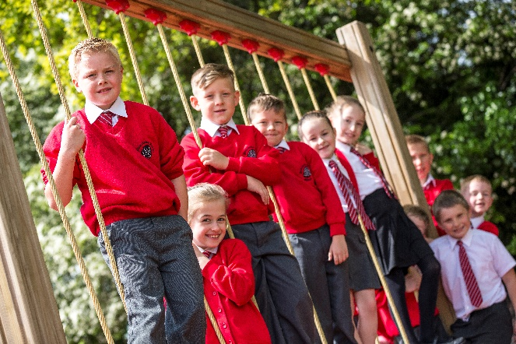
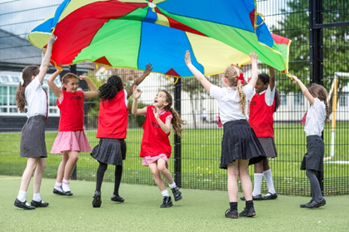

Parklands Junior School

Anti Bullying Policy

Statement of Intent

We are committed to providing a caring, friendly and safe environment for all of our pupils so they can learn in a relaxed and secure atmosphere. Bullying of any kind is unacceptable at our school. If bullying does occur all pupils should be able to tell and know that incidents will be dealt with promptly and effectively. We are a telling school. This means that anyone who knows that bullying is happening is expected to tell the staff.

What is Bullying?

Bullying is the use of aggression with the intention of hurting another person. Bullying results in pain and distress to the victim.
Bullying can be:

- Emotional - being unfriendly, excluding, tormenting (e.g. hiding books, threatening gestures);
- Physical - pushing, kicking, hitting, punching or any use of violence;
- Racist - racial taunts, graffiti, gestures;
- Sexual - unwanted physical contact or sexually abusive comments;
- Homophobic - because of, or focusing on the issue of sexuality;
- Verbal - name calling, sarcasm, spreading rumours, teasing;
- Cyber - all areas of internet, such as email and internet chat room misuse;
- Mobile threats by text messaging and calls. Misuse of associated technology, i.e. camera and video facilities

Why is it Important to Respond to Bullying?

Bullying hurts and no one deserves to be a victim of bullying. Everybody has the right to be treated with respect. Pupils who are bullying need to learn different ways of behaving.
We will respond promptly and effectively to issues of bullying.

Objectives of this Policy

- All governors, teaching and non-teaching staff, pupils and parents should have an understanding of what bullying is.
- All governors and teaching and non-teaching staff should know what the school policy is on bullying and follow it when bullying is reported.
- All pupils and parents should know what the school policy is on bullying and what they should do if bullying arises.
- As a school we take bullying seriously. Pupils and parents should be assured that they will be supported when bullying is reported.
- Bullying will not be tolerated.

Signs and Symptoms

A child may indicate by signs or behaviour that he or she is being bullied. Adults should be aware of these possible signs and that they should investigate if a child:

- Is frightened of coming to school;
- Changes their usual routine;
- Becomes withdrawn, anxious, or lacking in confidence;
- Cries themselves to sleep at night or has nightmares;
- Feels ill in the morning;
- Begins to do poorly in school work;
- Comes home with clothes torn or books damaged;
- Has possessions which are damaged or ‘go missing’;
- Asks for money or starts stealing money (to pay bully);
- Has tuck money or other monies continually ‘lost’;
- Has unexplained cuts or bruises;
- Becomes aggressive, disruptive or unreasonable;
- Is bullying other children or siblings;
- Stops eating;
- Is frightened to say what is wrong;
- Gives improbable excuses for any of the above.

These signs and behaviours could indicate other problems, but bullying should be considered a possibility and should be investigated.

Procedures

- Pupils must report bullying incidents to staff or Anti-bullying committee.
- Anti-bullying committee to be present in the playground to monitor incidents.
- Anti-bullying committee to meet once a week.
- In cases of serious bullying, the incidents will be recorded by staff.
- In serious cases parents should be informed and will be asked to come in to school for a meeting to discuss the problem.
- The bullying behaviour or threats of bullying must be investigated and the bullying stopped quickly.
- An attempt will be made to help the bully (bullies) change their behaviour.

Outcomes

- The bully (bullies) may be asked to genuinely apologise. Other consequences may take place: loss of free time and or privileges, representing Parklands Junior School at an event.
- In serious cases, suspension will be considered.
- If possible, the pupils will be reconciled. After the incident / incidents have been investigated and dealt with, each case will be monitored to ensure repeated bullying does not take place.
- Prevention.

We will use a variety of methods for helping children to prevent bullying. As and when appropriate, these may include:

- Writing a set of school rules;
- Signing a behaviour contract;
- Writing stories or poems or drawing pictures about bullying;
- Reading stories about bullying or having them read to a class or assembly;
- Making up role-plays;
- Having discussions about bullying and why it matters.

Date Approved: 9/2/2018
Review Date: 9/2/2019

